PROJECT REPORT STUDENT RECORD MANAGEMENT
SYSTEM (SRMS)


DONE BY
Saran Kumar Paidisetty (AP24110011562) Hareen Seethiraju (AP24110011563) Sanjay Reddy (AP24110011561)
Mahesh Yangalasetty (AP24110011595)

CSE 2ND YEAR FIRST SEMESTER
SECTION AE SUBMITTED TO Dr.PRAKASH
CODING SKILLS – I (CSE 201)

ABSTRACT

This project presents a Student Record Management System
developed in the C programming language to offer a reliable, secure and easy- to-use solution for managing student information. The system stores key details
such as roll number, name and marks in text files, ensuring that all data is safely preserved even after the program closes. It provides the essential operations
required for effective record management, including adding new entries,
viewing stored data, searching for specific students, updating information and deleting records when necessary.
A role-based login system forms the foundation of its security and usability. Users can log in as Admin, Staff or Guest, and each role is granted only the level of access needed for its responsibilities. Admin users can perform all
operations, staff users can view and search records and guest users are limited to viewing information. This structured approach not only protects the system
from unauthorized modifications but also makes the interface simple and user- friendly for every type of user.
Overall, this project demonstrates the practical importance of core C
programming concepts while showing how a straightforward application can effectively represent real-world data management. It stands as a highly valuable learning tool that combines simplicity, security and smooth usability to create a dependable student information management system.

INTRODUCTION

The Student Record Management System is a C-based
application developed to efficiently manage and maintain student information using basic file-handling techniques. The system stores essential details such as roll number, name, and marks in external text files, ensuring that the data
remains preserved even after the program is terminated. To ensure secure and organized access, the application incorporates a role-based login mechanism that restricts operations based on user privileges.
The system supports three distinct user roles: Admin, Staff, and Guest. Admin users possess complete access and can add, update, delete, search, and view
student records. Staff members are granted permissions to search and view existing records, whereas Guest users are limited to viewing the data. This
layered permission structure promotes data integrity and prevents unauthorized modifications.
In addition to managing student data, the project demonstrates the practical application of key concepts in the C programming language, including
structures, file operations, string handling, and conditional logic. Overall, the Student Management System serves as a foundational example of how real- world data management applications can be designed and implemented using fundamental programming principles.

OBJECTIVES

The main objectives of this project are:
- To create an easy and efficient system for managing student information using C programming.
- To add a secure login system with different roles for Admin, Staff and Guest users.
- To give each user type the right level of access so the system is used properly.
- To store student details in text files so the data can be saved for a long time and accessed easily.
- To allow Admin users to add, view, search, update and delete student records.
- To allow Staff users to only view and search student information without making any changes.
- To give Guest users read-only access to keep the data safe.
- To show the practical use of file handling, structures and conditional statements in C.
- To protect the accuracy of the data by preventing unauthorized changes.
- To provide a simple, user-friendly, menu-based interface for smooth and easy navigation.

MODULES
The system consists of the following major modules:

Login Module
  - Takes username and password.
  - Checks credentials from credentials.txt.
  - Identifies role: Admin, Staff, or Guest.

Role-Based Menu Module
  - Shows menu according to user role.
  - Controls access to operations for Admin, Staff, and Guest.

Student Addition Module (Admin Only)
  - Allows adding new student details.
  - Saves roll number, name, and marks in students.txt.

Display Students Module
  - Reads all records from students.txt.
  - Displays roll number, name, and marks.

Search Student Module
  - Searches for a student by roll number.
  - Shows matching record.

Update Student Module
  - Updates student name or marks.
  - Uses a temporary file to save updated data.

Delete Student Module (Admin Only)
  - Deletes a student record using roll number.
  - Rewrites file without the deleted entry.

File Handling Module
  - Handles reading and writing of credentials.txt and students.txt.

DATA FLOW DIAGRAM

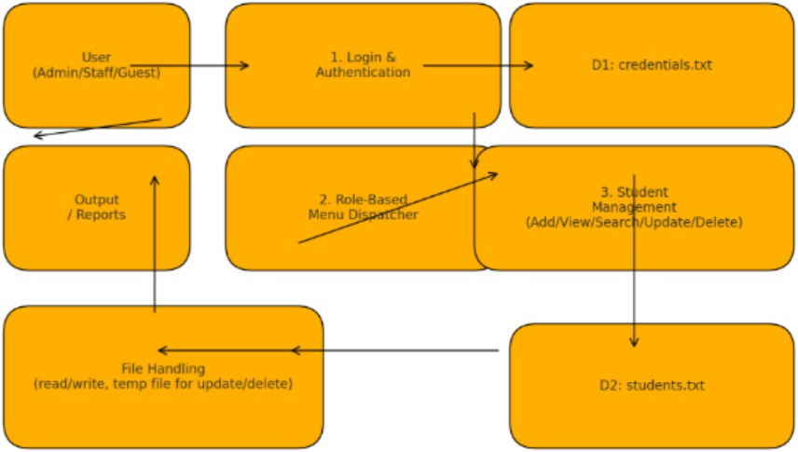

Explanation
- Login & Authentication:
The system checks the entered username and password with
credentials.txt and identifies the user role.
- Role-Based Menu:
Based on the role (Admin, Staff, Guest), the appropriate menu is shown and the chosen option is passed to the next process.
- Student Management:
Handles adding, viewing, searching, updating and deleting student
records. Updates and deletions use a temporary file for safe rewriting.
- File Handling:
All student data is stored in students.txt, ensuring permanent storage and reliable read/write operations.

CODE & OUTPUTS

students.txt
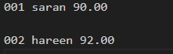

  - Credentials.txt

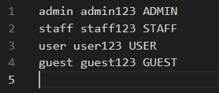

LOGIN & ADMIN MENU

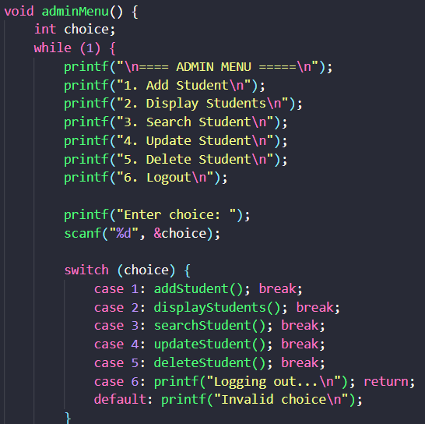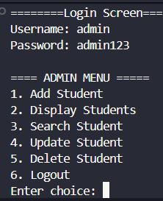
After login, the Admin Menu appears, allowing the admin to add, view, search, update, or delete student records.

ADD STUDENT
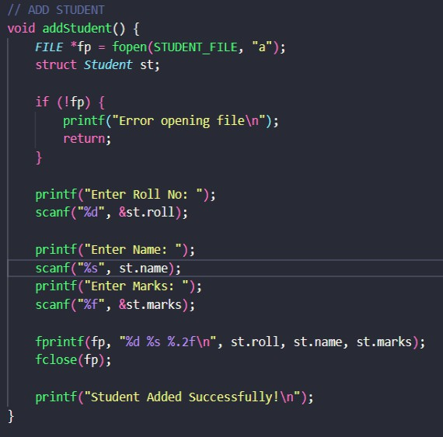
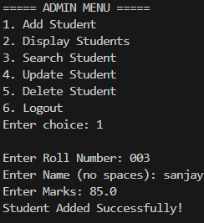
This screen allows the admin to add a new student record by entering the roll
number, name, and marks. After submission, the record is successfully stored in the system.

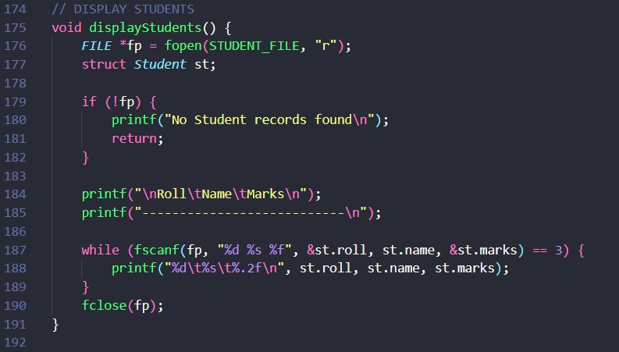
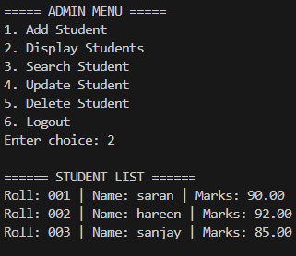
DISPLAY STUDENT

This output shows the list of all stored student records. It displays roll numbers, names, and marks in a structured table format.

SEARCH STUDENT

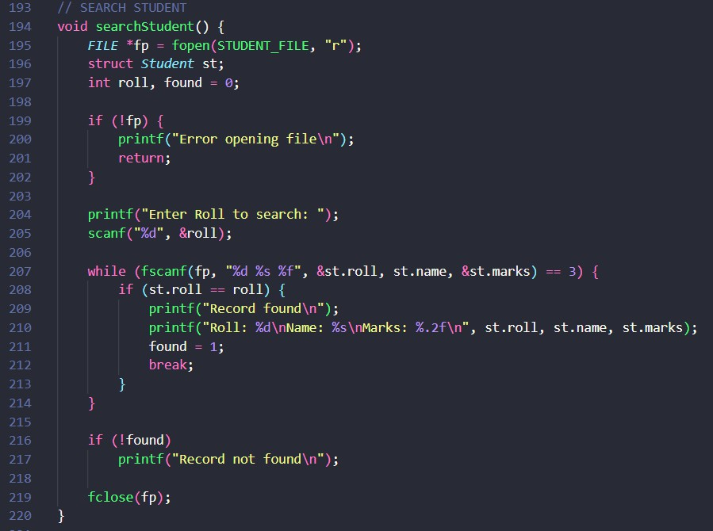
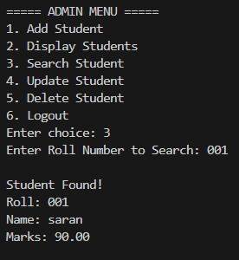
This screen lets the user search for a student using the roll number. If the record exists, the student's details are displayed.

UPDATE STUDENT

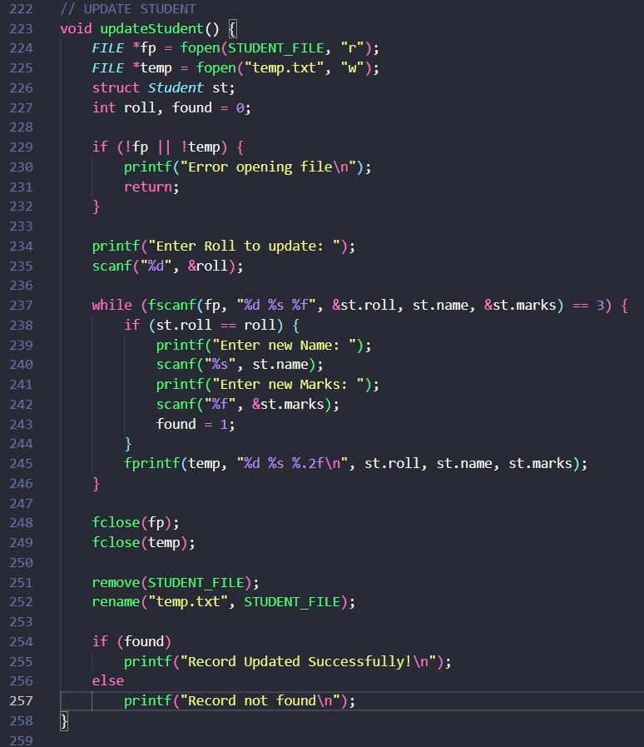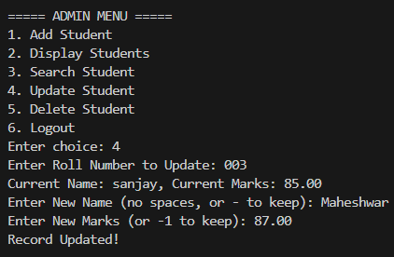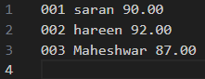

The update screen enables modification of an existing student’s details. The admin can update the student's name and marks after entering the roll number.

DELETE STUDENT
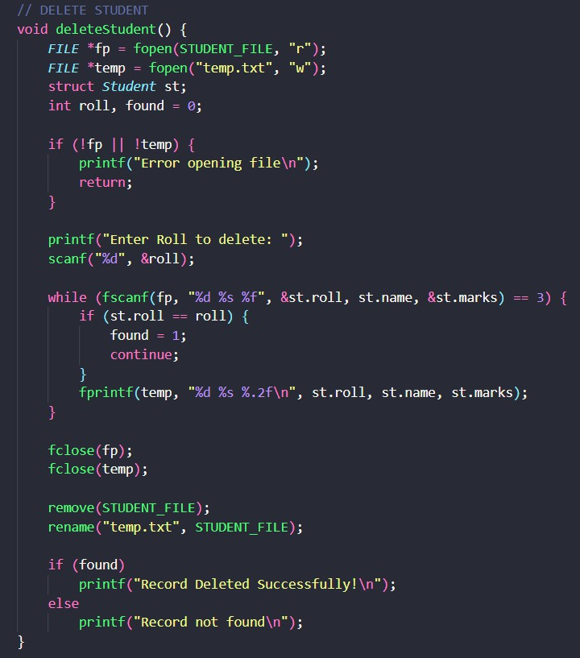
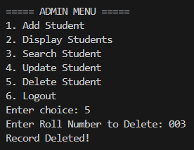
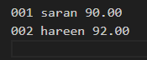
This output shows the result of deleting a student record. The system removes the matching roll number from the database and confirms the action.

CONCLUSION

The Student Record Management System is a simple program that helps store and manage student information in an easy and organised way. Users can add, view, search, update, and delete student records depending on their
role. Admin, Staff, and Guest users have different levels of access, which helps keep the records safe and prevents unwanted changes. The system is menu- driven and easy to understand, making it simple for anyone to use.

This project shows how basic C programming concepts like structures,
functions, loops, conditions, and simple file storage can be used to build a small working application. It performs all the main tasks needed for handling student records in a clear and reliable way. Overall, the Student Record Management
System is a good example of how useful applications can be created using simple and fundamental C programming techniques.

